Ex.No.15 Building anonymous FTP Scanner using ftplib module

AIM:
To build an anonymous ftp scanner using ftplib module in python.
Introduction:
FTP Scanner:
A tool that automatically scans IPs/hosts for active FTP servers. It tests connectivity and
credentials, reporting successful logins and vulnerabilities.
ftplib:
A built-in Python library for working with the File Transfer Protocol (FTP). It allows
connecting to FTP servers, logging in, listing directories, and transferring files.
ALGORITHM:
1. Start.
2. Import the ftplib module.
3. Specify the FTP server hostname.
4. Connect to the FTP server.
5. Log in using the username anonymous and password anonymous.
6. If the login is successful:
Display the login status.
Display the server&#39;s welcome message.
Display the directory listing.

7. Close the FTP connection.
8. If the login fails, display an error message.
9. Stop.

PROGRAM:

import ftplib
def anonymous_login(hostname):
try:
# Connect to the FTP server
ftp = ftplib.FTP(hostname)
# Login using anonymous credentials
response = ftp.login(&#39;anonymous&#39;, &#39;anonymous&#39;)
print(response)
# Check whether anonymous login is successful
if &quot;230&quot; in response:
print(&quot;\n[*] FTP Anonymous Login Succeeded.&quot;)
print(&quot;Server:&quot;, hostname)
# Display welcome message
print(&quot;\nWelcome Message:&quot;)
print(ftp.getwelcome())
# Display directory listing
print(&quot;\nDirectory Listing:&quot;)
ftp.dir()
# Close the FTP connection
ftp.quit()
except Exception as e:
print(&quot;Error:&quot;, e)
print(&quot;\n[-] FTP Anonymous Login Failed.&quot;)
# Main Program
hostname = &quot;ftp.be.debian.org&quot;
anonymous_login(hostname)

SAMPLE OUTPUT:
230 Login successful.

[*] FTP Anonymous Login Succeeded.
Server: ftp.be.debian.org

Welcome Message:
220 FTP Server Ready

Directory Listing:
drwxr-xr-x 2 ftp ftp 4096 Jan 10 2026 debian
drwxr-xr-x 2 ftp ftp 4096 Jan 10 2026 cdimage
drwxr-xr-x 2 ftp ftp 4096 Jan 10 2026 project
-rw-r--r-- 1 ftp ftp 512 README.txt

221 Goodbye.

OUTPUT:
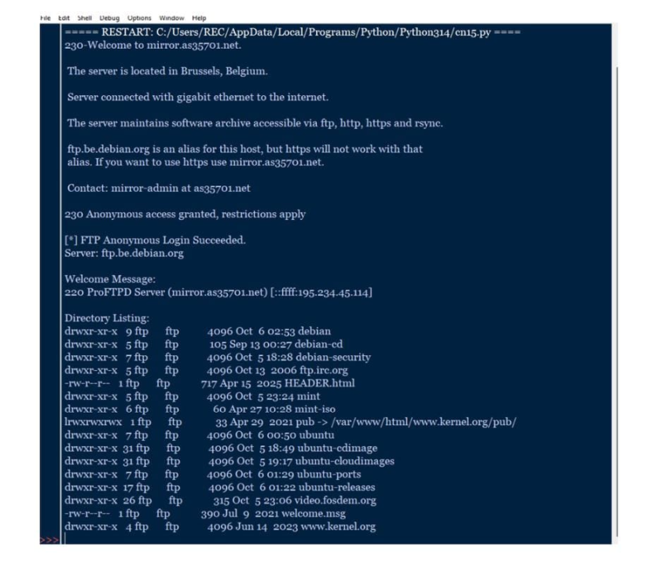
RESULT:
Thus an anonymous ftp scanner using ftplib module was built and executed successfully.

